**Configuring SSO with Azure Active Directory in**

**Talend cloud**

#Adding Talend Cloud Management Console to Active Directory Applications.

**#Before you begin**

You must have an Azure Active Directory subscription.

**#Procedure**

1. Log in to the Microsoft Azure portal.
2. Click **Azure Active Directory** on the navigation panel.
3. Go to **Enterprise Applications** and select **All applications**.
4. Add a **New application**.
5. Select **Non-gallery application**, then enter a name for the new application and click **Add** to save it

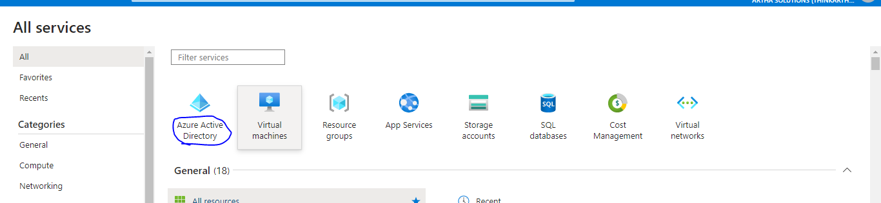

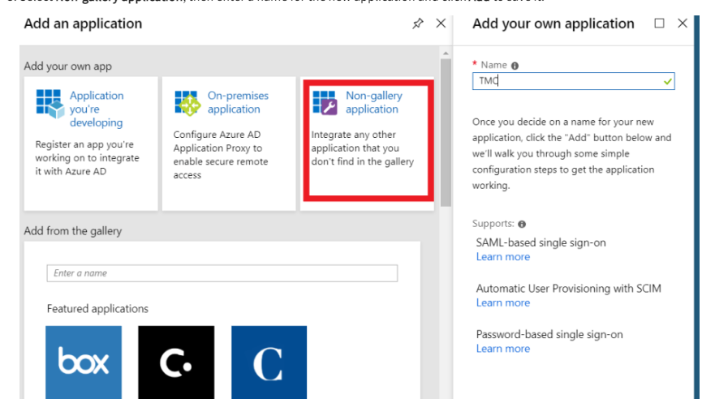

**#Configuring Azure AD Single Sign-On**

**Procedure**

1. Go to the **All applications** view of **Azure Active Directory** on the Azure portal and select the application created earlier for Talend Cloud Management Console.
2. Select **Single sign-on**.

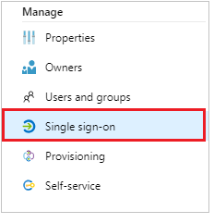

c. On the **Select a single sign-on method** dialog, select **SAML**.

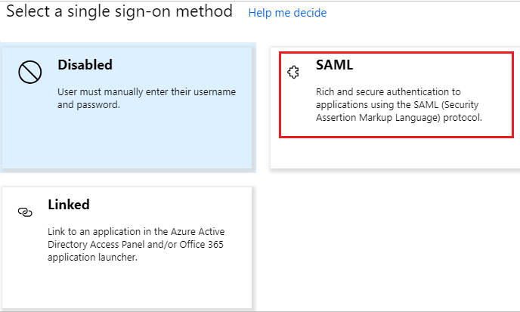

1. On the **Set up Single Sign-On with SAML** page, click the **Edit** icon in the **Basic SAML Configuration** section.

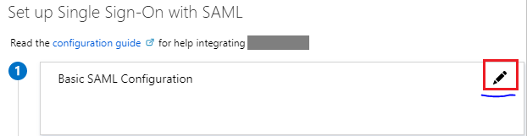

**e**. Specify an Identifier and the Reply URL in the Basic SAML Configuration section and next to the Identifier

check box, select the default check box to set Talend Cloud SSO URL as the default value.

Identifier (Entity ID): Talend Cloud SSO URL.

For example:

AWS: https://iam.us.cloud.talend.com/oidc/ssologin

Azure: https://iam.us-west.cloud.talend.com/oidc/ssologin

#This identifier must be unique in your organization.

When you need to set up SSO for multiple accounts (multiple tenants) on Talend Cloud Management Console, use their account IDs to define the unique entity ID of each account. For example, the entity ID for the AWS US region above becomes https://iam.us.cloud.talend.com/oidc/ssologin/<your_account_ID>.

You can find the account ID on the **Subscription** page of your Talend Management Console.

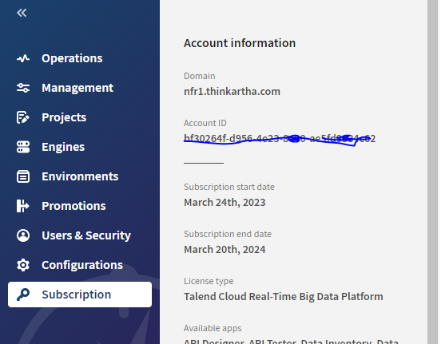

**f.** Click **Save**.

**g.** Edit the **User Attributes & Claims** to include the attributes required in Talend Cloud Management Console

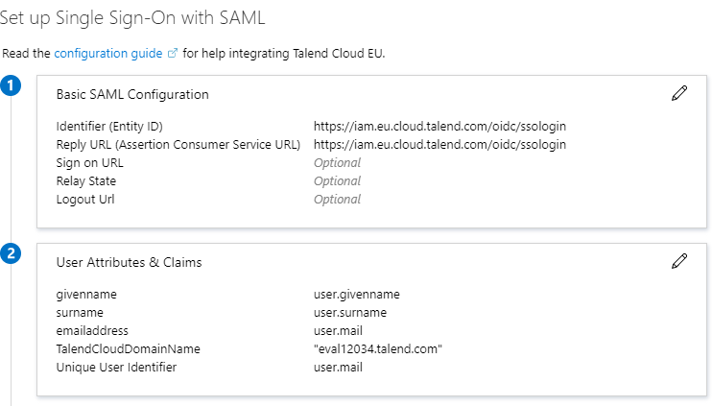

Talend Cloud Management Console requires the following attributes:

i) email address: enter user.mail

ii) given name: enter user.givenname

iii) surname: enter user.surname

iv) TalendCloudDomainName, enter mydomain.talend.com within double qotation marks, for example, "eval12345.talend.com". The value of the TalendCloudDomainName attribute is your Talend Cloud account name:

If you already logged in Talend Cloud, find the account name in the Domain field of the Subscription page of your Talend Management Console.

v) middlename: enter user.middlename

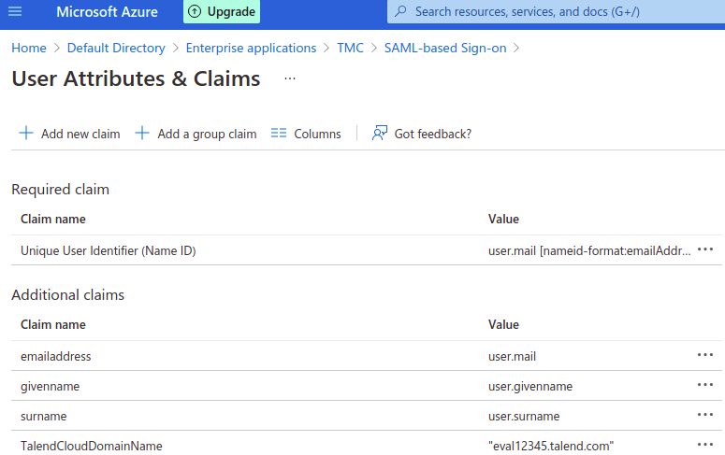

**h.** On the **Set up Single Sign-On with SAML** page, go to the **SAML Signing Certificate** section and download the **Federation Metadata XML** file.

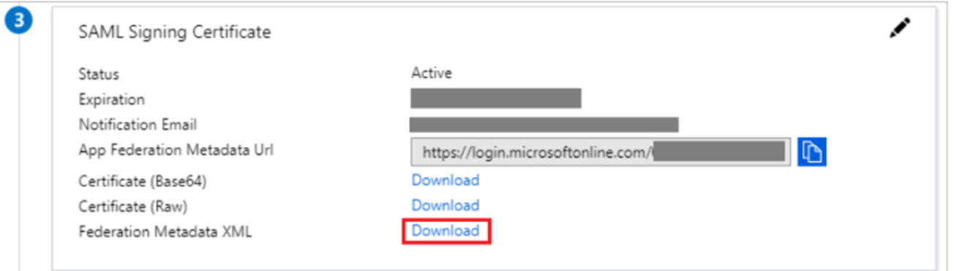

The downloaded metadata.xml file must specify a NameIDFormat.

If this is not the case, add the following line in the <IDPSSODescriptor> area in this file: <NameIDFormat>urn:oasis:names:tc:SAML:1.1:nameid-format:emailAddress</NameIDFormat>

**i.** Copy the URL in the **Login URL** field.

This URL will have to be provided in Talend Cloud Management Console to enable SSO

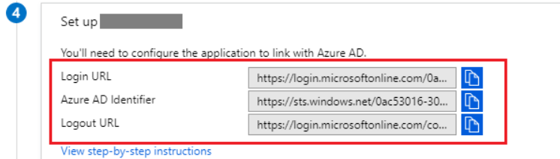

**Enabling SSO in Talend Cloud Management Console**

**#Before you begin**

You must have the Security Administrator role in Talend Cloud Management Console.

You must have the metadata file obtained from the SSO provider.

**#Procedure**

1. Log in to Talend Cloud Management Console.
2. On the top of the Users page, click Authentication.
3. Click Configuration.
4. Enter the SSO provider domain name in the Organization URL field.
5. This domain name is the Login URL you copied from your Azure portal when configuring Azure AD Single Sign-On in the previous steps.
6. Upload the metadata file you downloaded from the SSO application configuration by clicking the icon.
7. Check the default User attributes. If needed, edit them to match the application configuration specified on the SSO provider side.
8. These attributes are propagated to the SAML token used to authenticate users. The application configuration on the SSO provider side must specify these attributes as well as two other attributes:
9. The TalendCloudDomainName attribute that indicates your Talend Cloud account name. You can find the account name in the Domain field of the Subscription page of your Talend Management Console.
10. The NameId Format attribute that indicates the email address format.
11. Click Test to check your configuration.

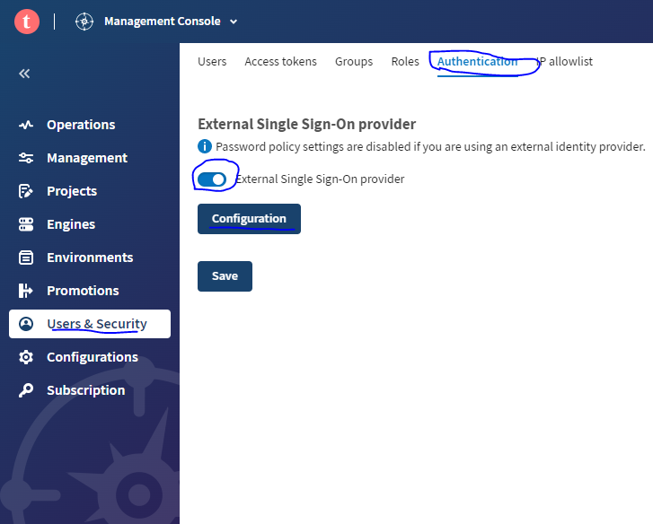

L. **Optional:**Set up user provisioning to automatically create users in Talend Cloud Management Console when logging in to a Talend Cloud application via the identity provider.

M. **Optional:**Customize the logout URL. For example, redirect users to a specific page. By default, users are redirected to the Talend Cloud login page when they log out.

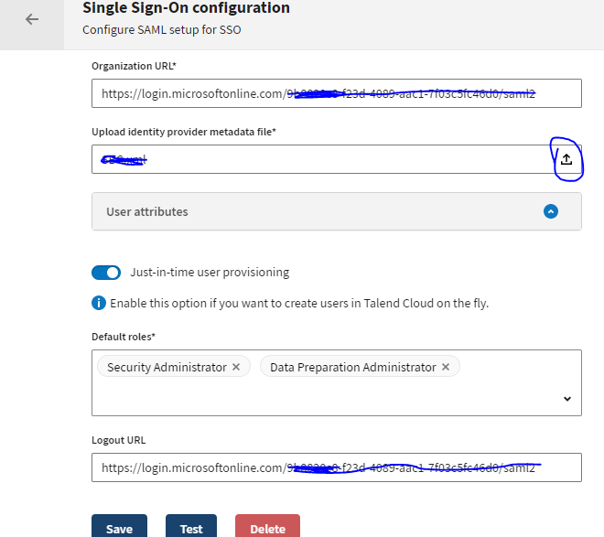

N. Click **Save and Activate**.

**Testing Single Sign-On with Azure AD**

**#Before you begin**

You have configured your application in the Azure portal and enabled SSO from Talend Cloud Management Console.

**#Procedure**

1. Go to [https://login.microsoftonline.com](https://login.microsoftonline.com/) to find the application created in Azure Active Directory.
2. Scroll to the **Validate single sign-on** section and click **Validate**.
3. Select **Sign in as current user**. This test lets you check if the enabled configuration works for your administrator account.